NAAN MUDHALAVAN

Welocome To My
( project)

>Laptop Request
Catalog Item<

Team Id:NM2025TMID17244

Team Leader: R Lokesh kumar
Team member:P Deepika
Team member: Saritha
Team member:N Ramya

Laptop Request
Catalog Item

Laptop Request Catalog Item
Problem Statement:
Employees in the organization need a quick and efficient way to request laptops for work. The current process is manual and prone to delays, with no dynamic form behavior to guide users or ensure accurate data collection. To address this, a Service Catalog item needs to be created, allowing users to easily request a laptop, with dynamic fields, clear instructions, and additional functionality like resetting the form if needed. The solution should also ensure all changes are tracked for governance and deployment.

Update Set

Servive Catalong Item
Create Service Catalog Item
- Open service now.
- Click on All >> service catalog
- Select maintain items under catalog definitions
- Click on New.

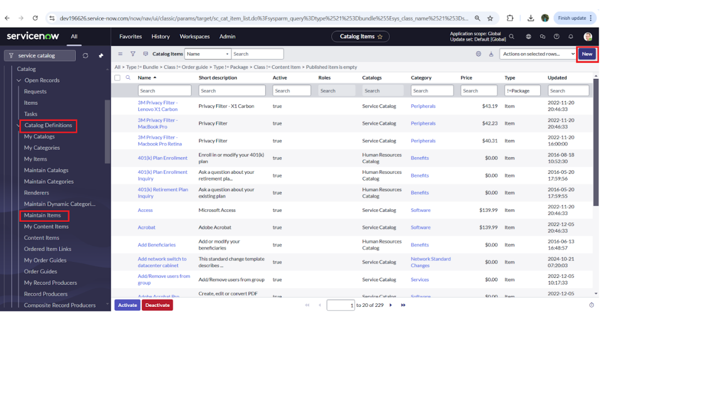

- Fill the following details to create a new catalog item
Name: Laptop Request
Catalog: service Catalog
Category: Hardware
Short Description: Use this item to request a new laptop
- Click on ‘SAVE’
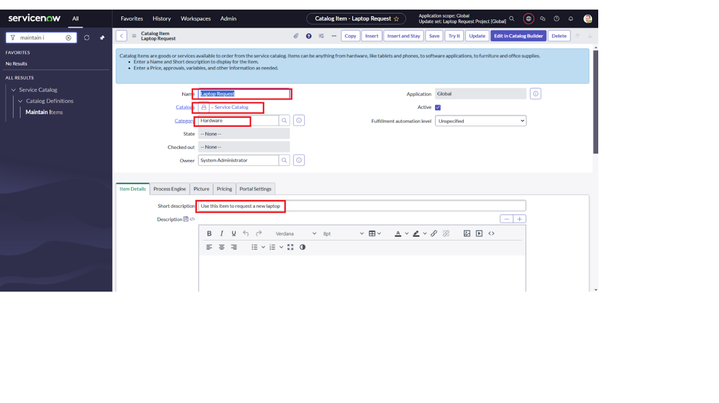

Add variables
Step1:
- After saving the catalog item form scroll down and click on variable(related list)
- Click on new and enter the details as below
1. Variable 1:Laptop Model
Type: Single line text
Name: laptop_model
Order:100
- Click on submit
- Again click on new and add Remaining variables in the above process

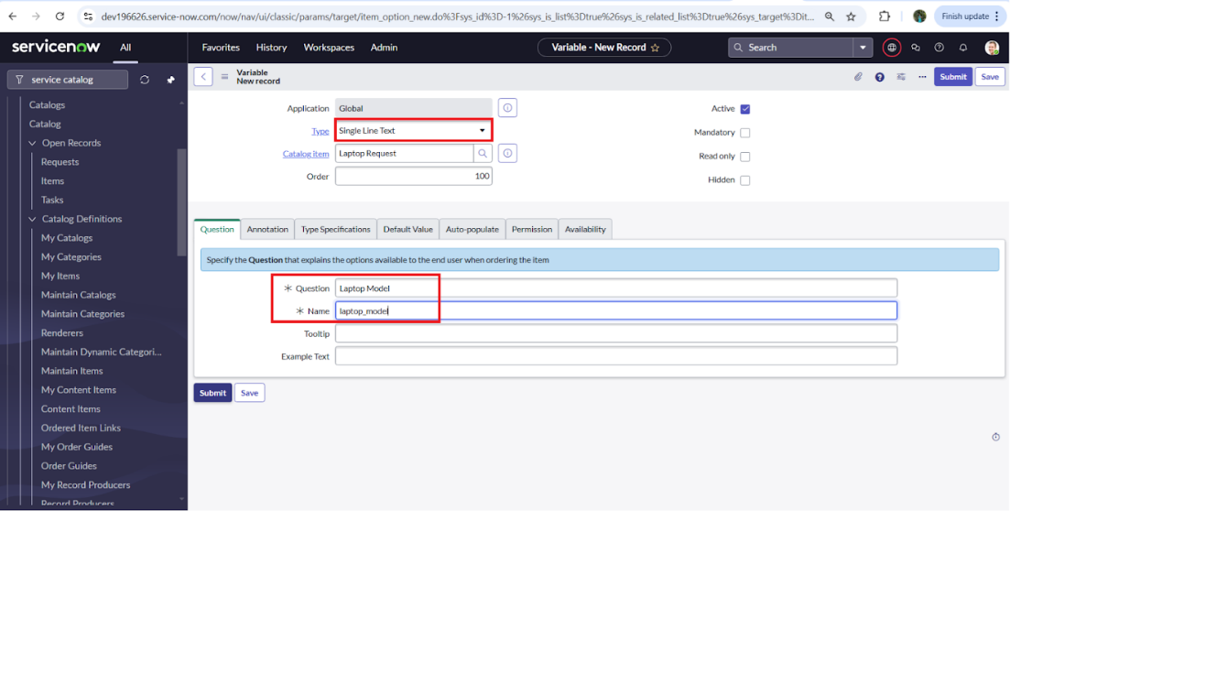

2. Variable 2:Justification
Type: Multi line text
Name: justification
Order:200
3. Variable 3:Additional Accessories
Type: Checkbox
Name: additional_accessories
Order:300
4. Variable 4: Accessories Details
Type: Multi line text
Name:accessories_details
Order:400
Step2:
- After adding above variable which are added to newly created catalog item
- Then save the catalog item form
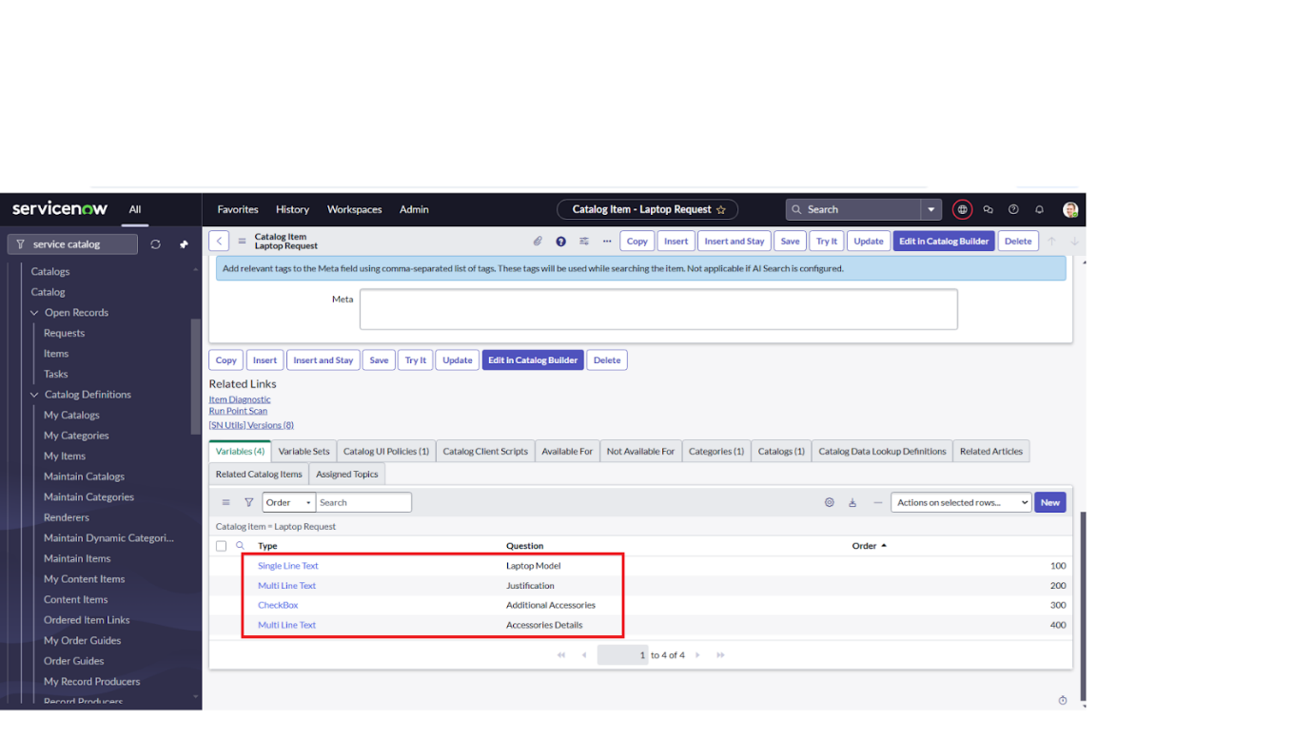

UI Policy
Create Catalog Ui policies
- Click on all>> search for service catalog
- Select maintain item under catalog definition
- Search for ‘laptop request’ which is created before
- Select ‘laptop request’ and scroll down click on “Catalog Ui policies”
- In the catalog ui policies related list tab click on new
- Give short description as: show accessories details
- Set the Catalog Condition in the related list tab ‘when to apply’
[field: additional_ accessories, operator: is, value: true]
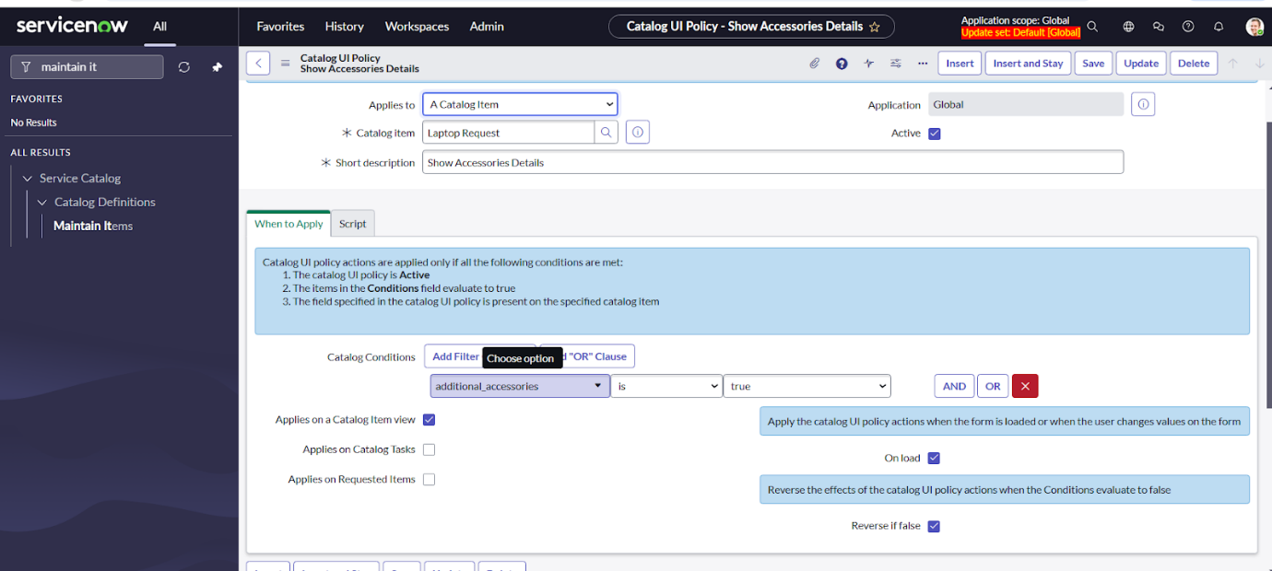

- Click on save.(do not click on submit)
- Scroll down and select ‘catalog ui action’
- Then click on new button
- Select variable name as: accessories_details
Order:100
Mandatory: True
Visible : True

- Click on save and again click save button of the catalog ui policy form

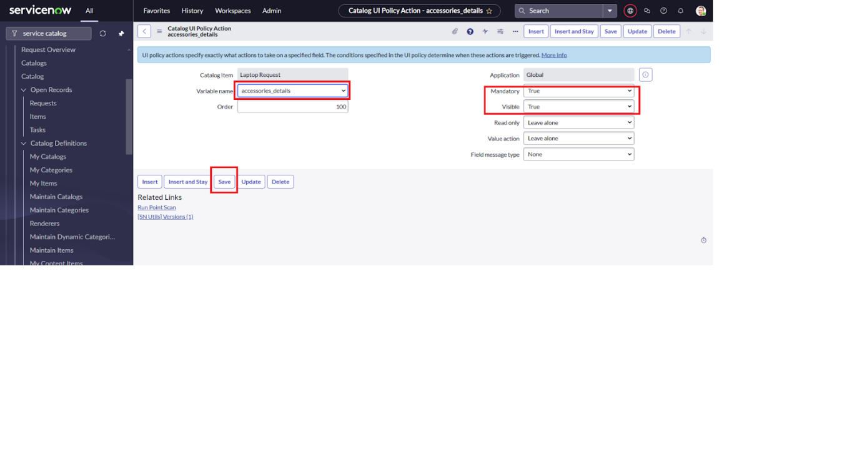
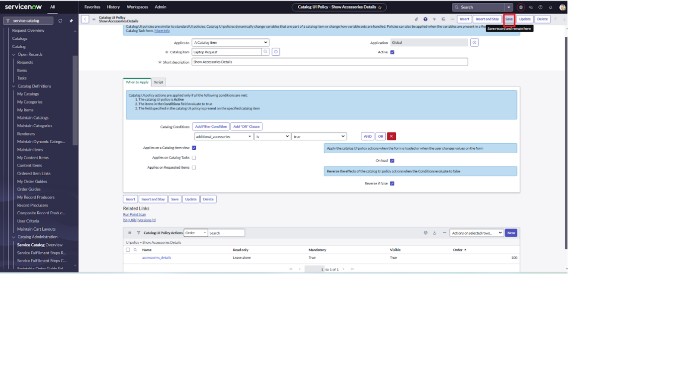

UI Action
Create ui action
- Open service now.
- Click on All >> search for ui action
- Select ui actions under system definition
- Click on new
- Fill the following details to create ui action
Table: shopping cart(sc_cart)
Order:100
Action name: Reset form
Client : checked
Script:
function resetForm() {
g_form.clearForm(); // Clears all fields in the form
alert("The form has been reset.");
}
6. Click on save
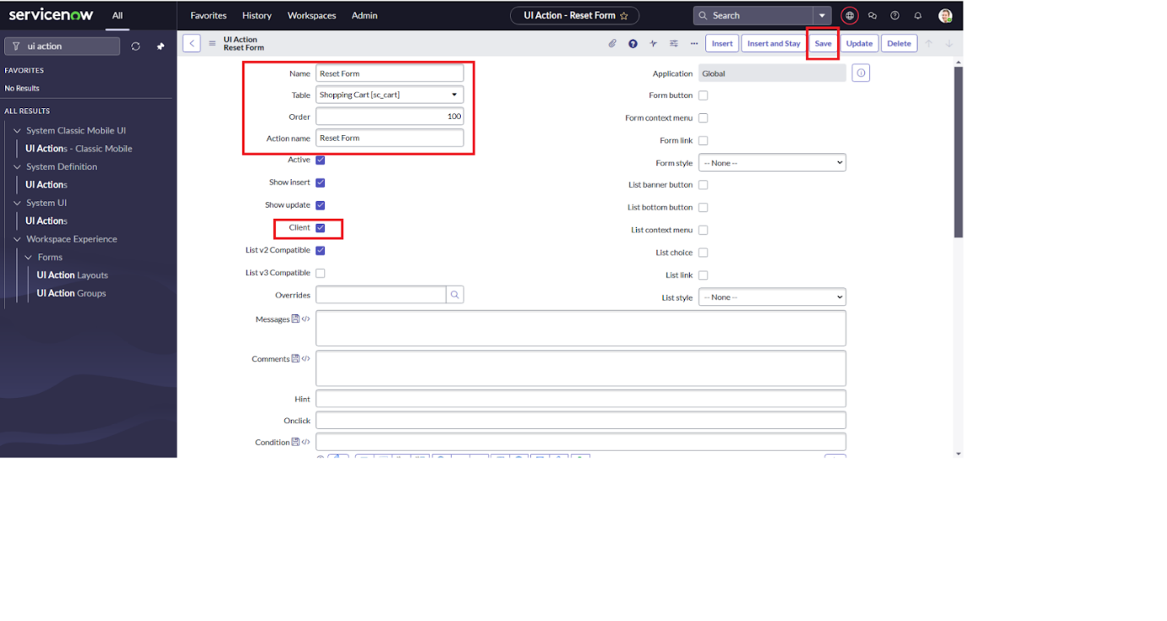

Export Update set
Exporting changes to another instances
- Click on All >> search for update sets
- Select local update set
- Select created update set i.e. ‘Laptop Request Project’
- Set the state to ‘Complete’
- In the related list Update tab, updates are visible which we perform under this update set.
- Click on export to XML ,it download one file

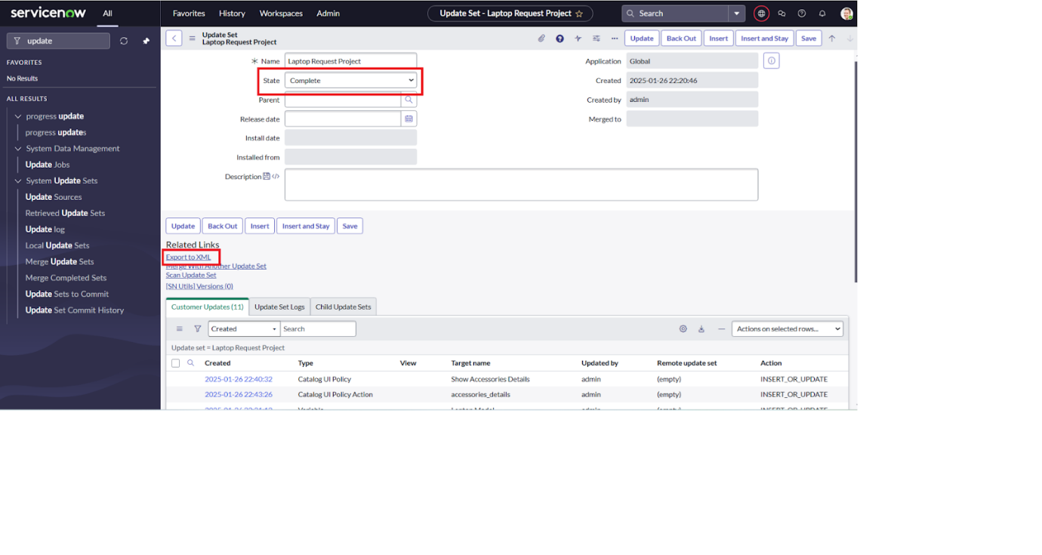

Login to another Instance
Retrieving the update set

- Open another instance in incognito window
- Login with credentials
- Click on all>> search for update sets
- Select “Retrieved update set” under system update set
- It open retrieved update set list and scroll down
- Click on Import update set from XML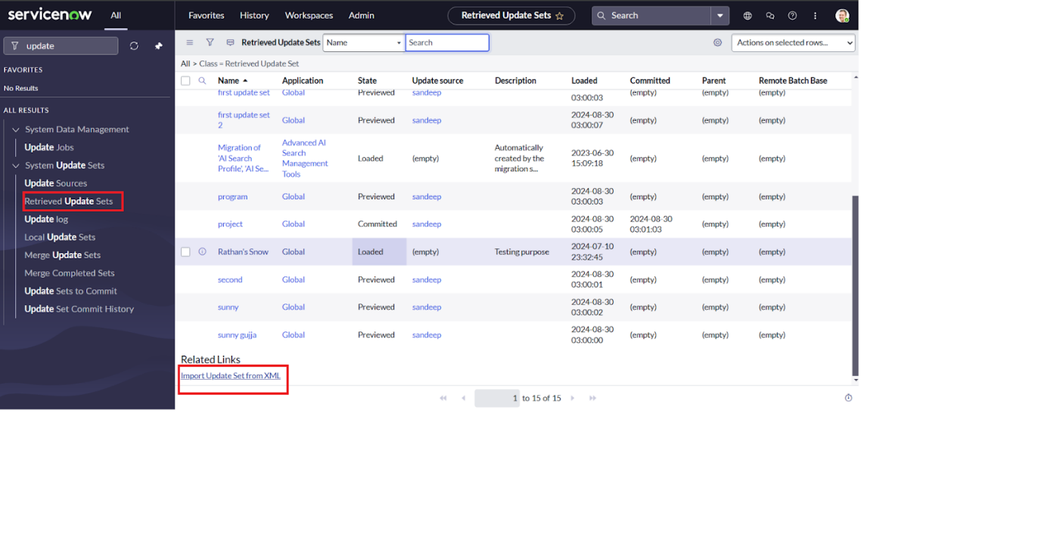
- Upload the downloaded file in XML file
- Click on Upload and it gets uploaded.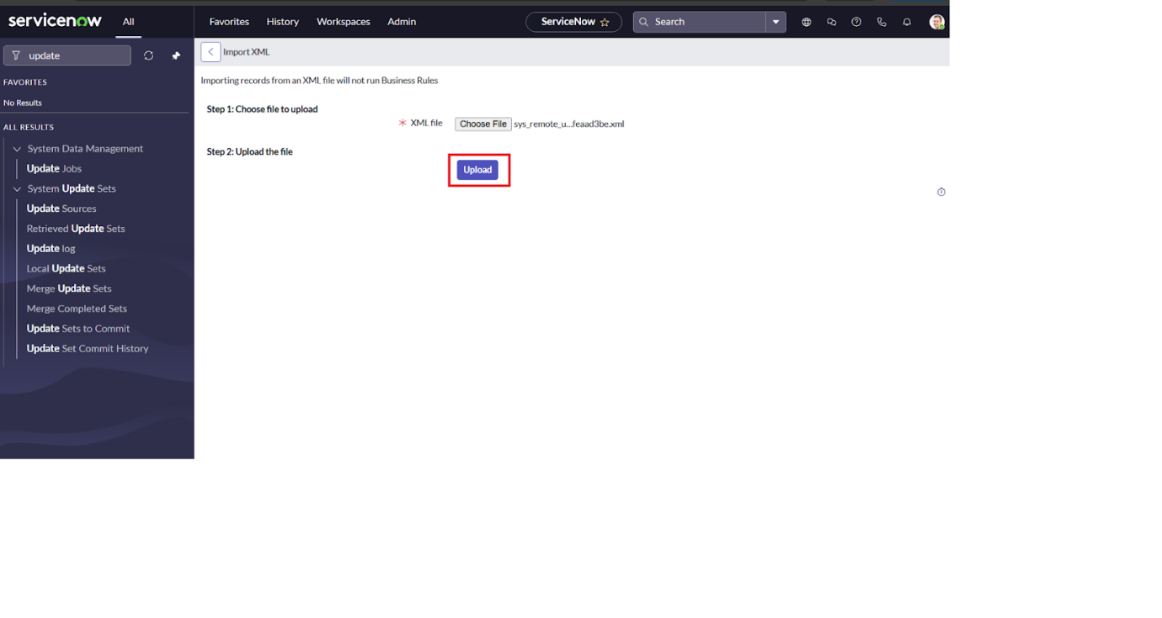
- Open retrieved update set ‘laptop request project’
- Click on preview update set
- And click on commit update set
- And also see the related tab updates
- After commiting update set in this instance we get all updates which are done in the previous instance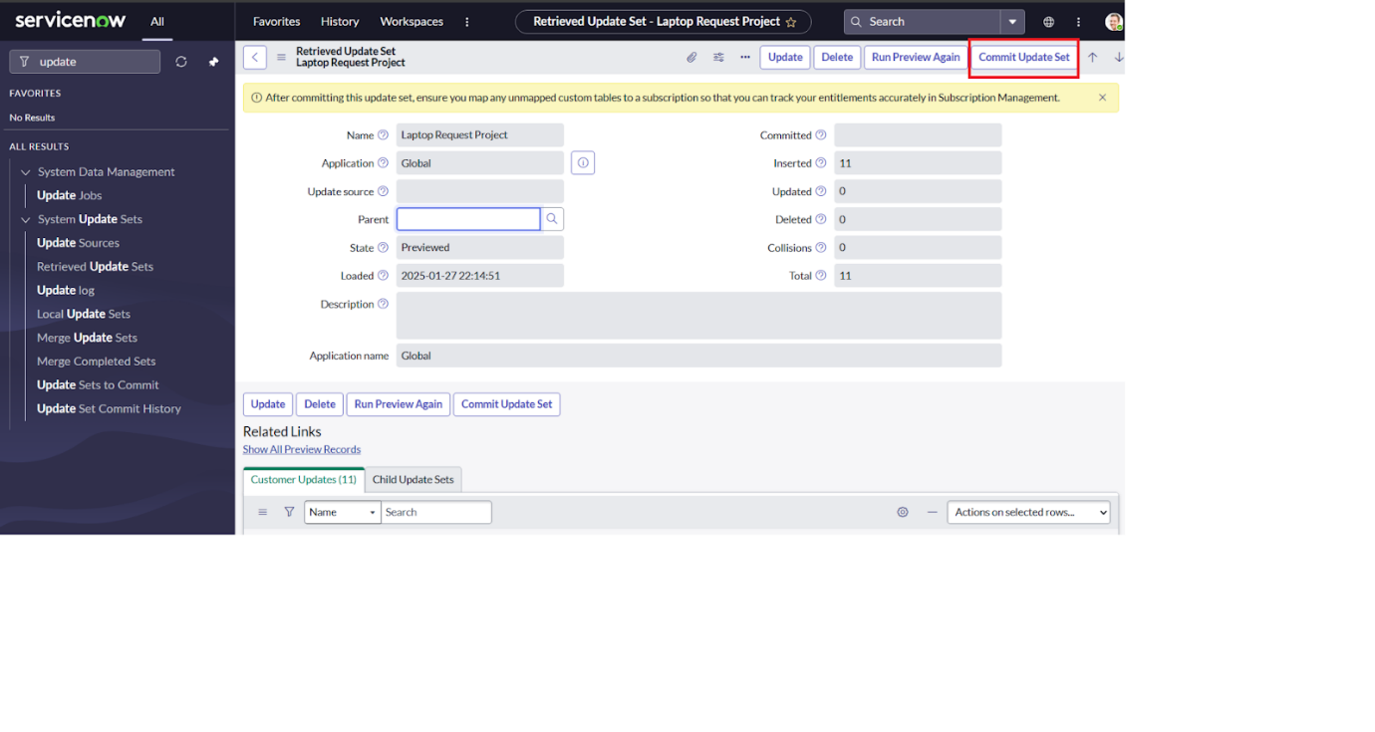

Testing
Test Catalog Item
- Search for service catalog in application navigator in target instance
- Select catalog under service catalog
- Select hardware category and search for ‘laptop request’ item
- Select laptop request item and open it
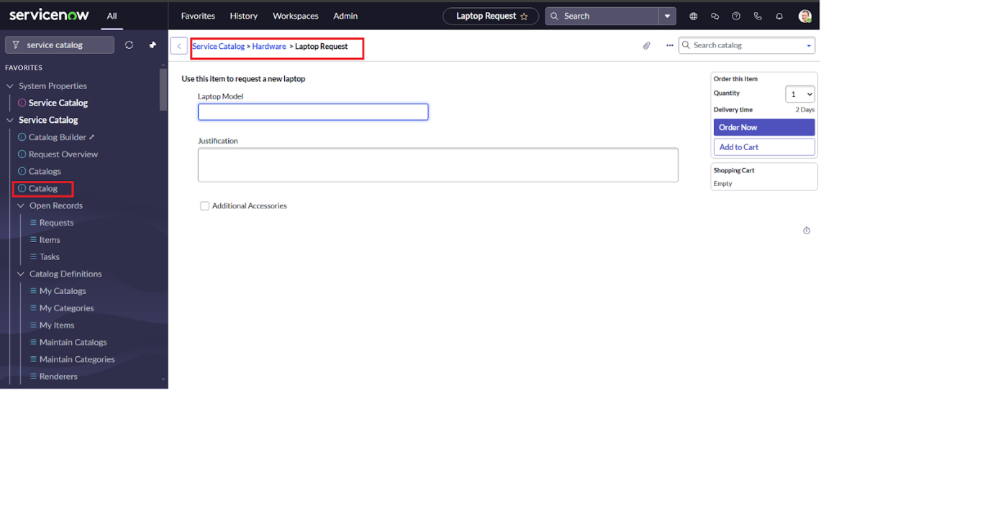
- It shows three variables only
- As per our scenario, when we click on additional accessories checkbox then accessories details fields is visible and that should be mandatory
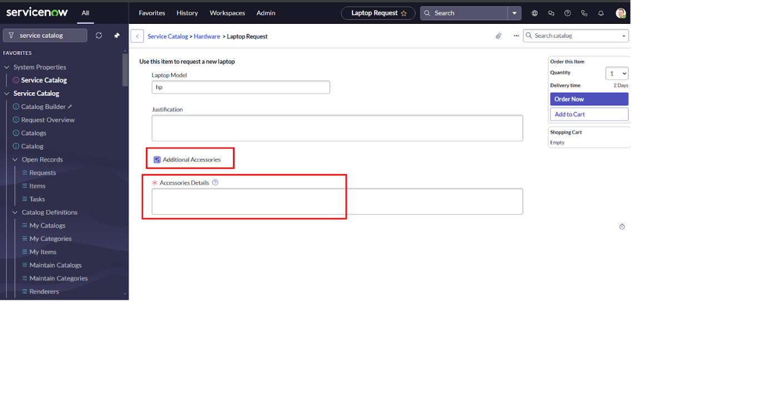
- Now see the results,it fulfills our requirements.

Conclusion :

The Laptop Request Catalog Item project successfully streamlines the process of requesting laptops within the organization by leveraging ServiceNow's Service Catalog capabilities. Through the implementation of a dynamic catalog item, the project ensures that users have an intuitive and user-friendly interface, reducing errors and improving efficiency.This project demonstrates how ServiceNow can be used to replace manual, error-prone processes with automated, efficient, and user-centric solutions. It not only improves service delivery but also enhances employee satisfaction by providing a modern and streamlined request experience.

